English Long-Term Plan

 | Autumn 1 | Autumn 2 | Spring 1 | Spring 2 | Summer 1 | Summer 2
Genre & Text | Narrative  Lost and Found (Oliver Jeffers)  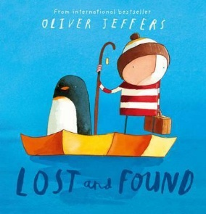 | Narrative  Babushka  (Sandra Ann Horn)  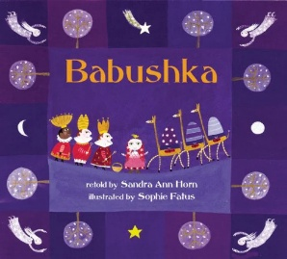 | Narrative  Man on the Moon  (Simon Bartram)  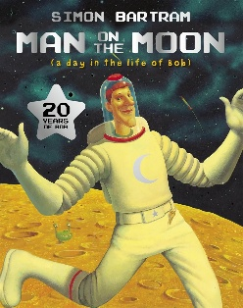 | Narrative  Grandad’s Island  (Benji Davies)  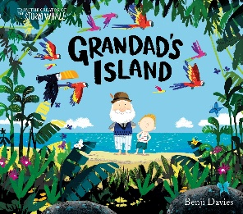 | Narrative  Cinnamon  (Neil Gaiman)  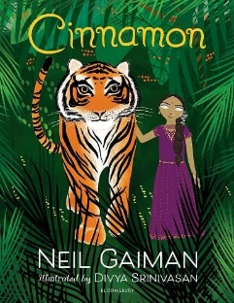 | Narrative  The True Story of the Three Little Pigs (Jon Scieszka)  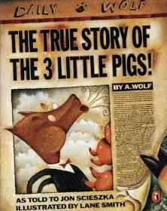
Writing Outcome | Story Retell  Character description | Story Retell  Character description | Story Retell  Setting description | Story Retell  Setting description | Character Description  Setting description | Story Retell  Character Description
Why this, why now? | Lost and Found introduces children to the work of Oliver Jeffers and broadening their experience of high-quality authors. Building on the retelling skills developed through talk for write in EYFS, pupils progress to writing character descriptions through dictated sentences. | Babushka has been chosen to expose children to a wider range of cultures, building on their experience of The Christmas story in Reception. The text offers a traditional Russian tale to the familiar Christian Story, broadening their understanding of the world. Children will be applying their writing skills through character descriptions and story retells. | Man on the Moon introduces children to the work of Simon Bartram and broadening their experience of high-quality authors. Building on the retelling skills developed through Autumn term, pupils progress to writing in the first-person, using time adverbials and apply their writing skills to a setting description. | Grandad’s Island has been chosen to broaden children’s experience of different text types and authors.  The book offers rich and ambitious vocabulary, providing valuable opportunities for language development. Children will apply their writing skills through activities such as story retelling and setting descriptions. | Cinnamon has been chosen to expose children to a wider range of texts. The text offers opportunities to explore Indian culture, broadening their understanding of the world. The story also provides insight into disability, with a blind protagonist at its centre.  Children will be applying their writing skills through both character and setting descriptions. | The True Story of the Three Little Pigs has been chosen to build on children's knowledge of traditional tales from Reception by introducing a familiar story with an unexpected twist. This supports pupils in comparing texts and developing more sophisticated writing in preparation for Year 2.

